Hello Dear Friends and Family!
“I`m dreaming of a white Christmas..” One can only dream of that while living in Australia. So here I am, Townsville Australia, 30 degrees, a day and a bit ahead of all of you back home. But as I write this, I rock the Canadian flag on my laptop; I don’t ever forget where I came from.
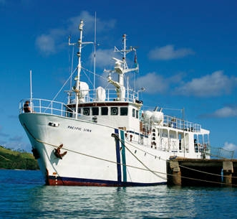
I’m sure that for a lot of you back home, what I do over here is a little bit confusing, or when I try to explain what I do, it just sounds like words flowing out of my mouth. I wish I could explain a little bit better, but I AM only human. So I`ll explain to my best ability what it is that’s happening around the base (where everything YWAM Reef to Outback takes place) and what I do.
What YWAM RTO is really focusing on right now is our Medical Ship Ministry, which helps in taking dentistry, doctors, etc, into Papua New Guinea via the ship. It`s a really exciting time here because our current ship is great, but we`re looking into building from scratch a bigger, more reliable ship which is said to be completed sometime in 2013. The ship is one of the main reasons I returned to YWAM, in hopes that I could eventually serve on the ship and in PNG once again, whatever that may look like.
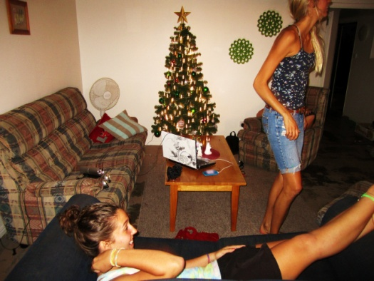
What I personally am a part of at this time, is working with our base director Ken Mulligan, helping him in the busy season to keep things organized and get work done. I love being a part of something so huge, but what I do really breaks things down to make me understand more of what’s going on. Working full time in the “Directors Office” really helps me to rely on God so much because all in all I really don’t know what I’m doing! But God keeps me focused and allows me to have fun and realize I’m doing it all for him.
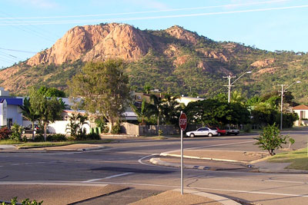
The other night the girls I live with, and I, set up our Christmas tree in our living room while listening to the classic Frank Sinatra and Bing Crosby Christmas music. It made me really miss Kelowna’s white Christmases. But being home with all the girls who really are basically like family, made it feel like a piece of home was here with all of us. I’ve been able to hike up Castle Hill on a regular basis. It’s a “mountain” behind our base. It’s a good place to get away and pray and just be alone.
I hope you are all doing well! I pray this gives you a better sense of what I’m doing over here. Thank you for all your prayers and support!
Love, Amy

